MODULE 4 – INTRODUCTION TO DBMS

LAB EXERCISES

22. SQL Cursors
Lab 1.
Write a PL / SQL block using an explicit cursor to fetch and display all records from the members table.
Ans.
1. DELIMITER $$

CREATE PROCEDURE fetch_all_members()

BEGIN

DECLARE v_member_id INT;
DECLARE v_member_name VARCHAR(255);
DECLARE v_date_of_membership DATE;
DECLARE v_email VARCHAR(255);
DECLARE done INT DEFAULT 0;

DECLARE member_cursor CURSOR FOR
SELECT member_id, member_name, date_of_membership, email FROM members_backup;

DECLARE CONTINUE HANDLER FOR NOT FOUND SET done = 1;

OPEN member_cursor;

read_loop: LOOP
FETCH member_cursor INTO v_member_id, v_member_name, v_date_of_membership, v_email;
IF done THEN
LEAVE read_loop;
END IF;

SELECT
v_member_id AS MemberID,
v_member_name AS Name,
v_date_of_membership AS DateOfMembership,
v_email AS Email;
END LOOP;

CLOSE member_cursor;
END$$

DELIMITER ;

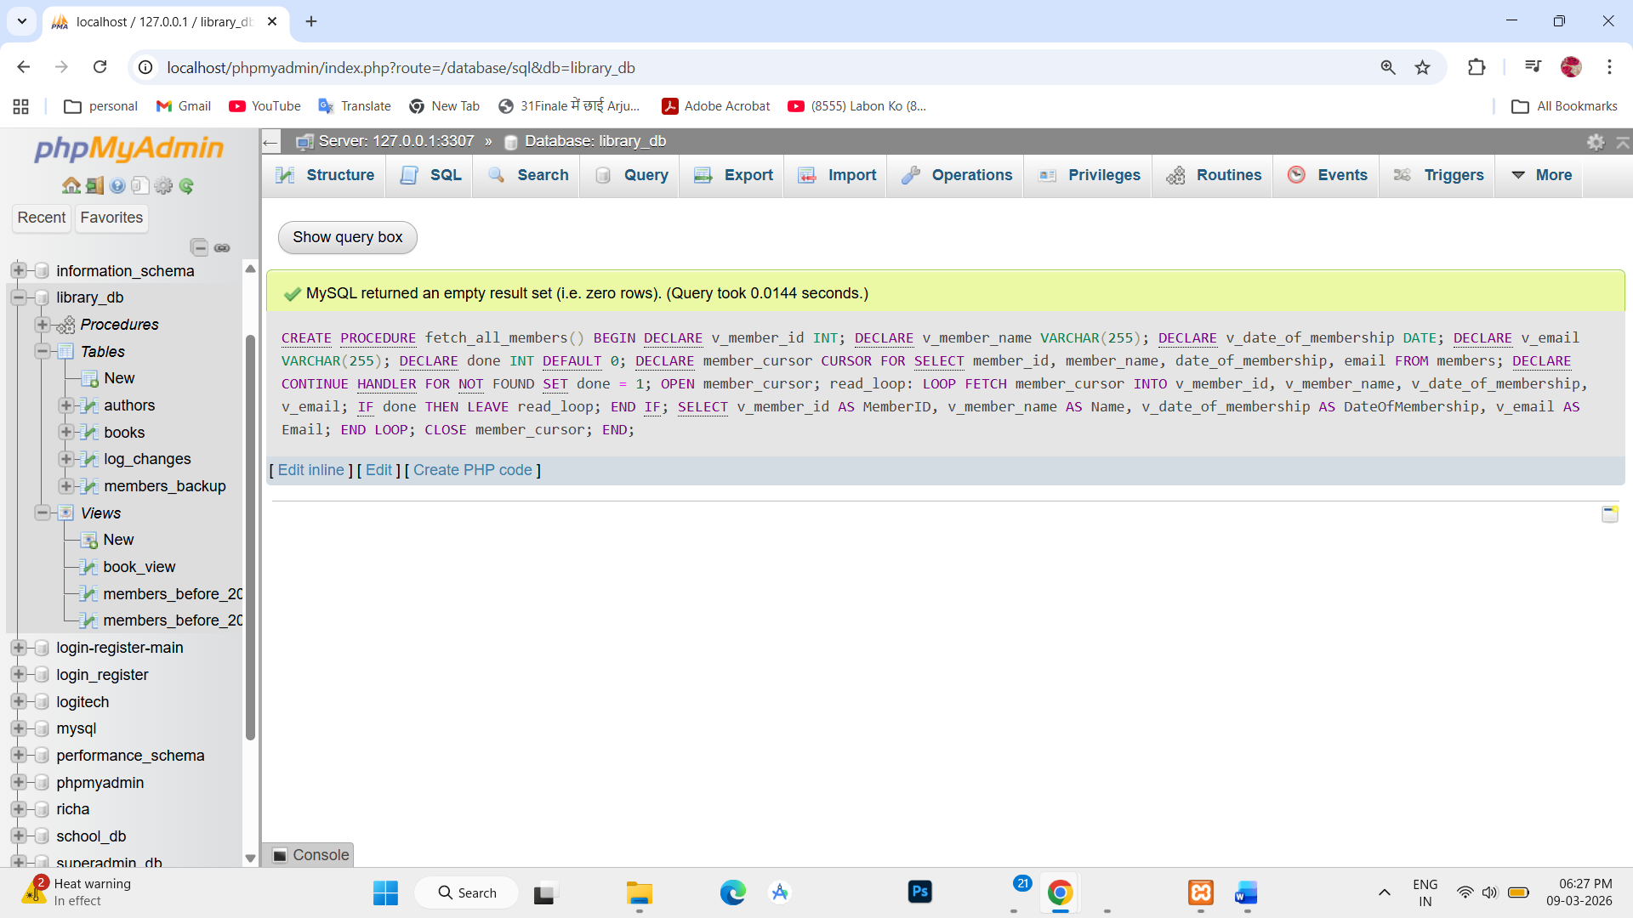

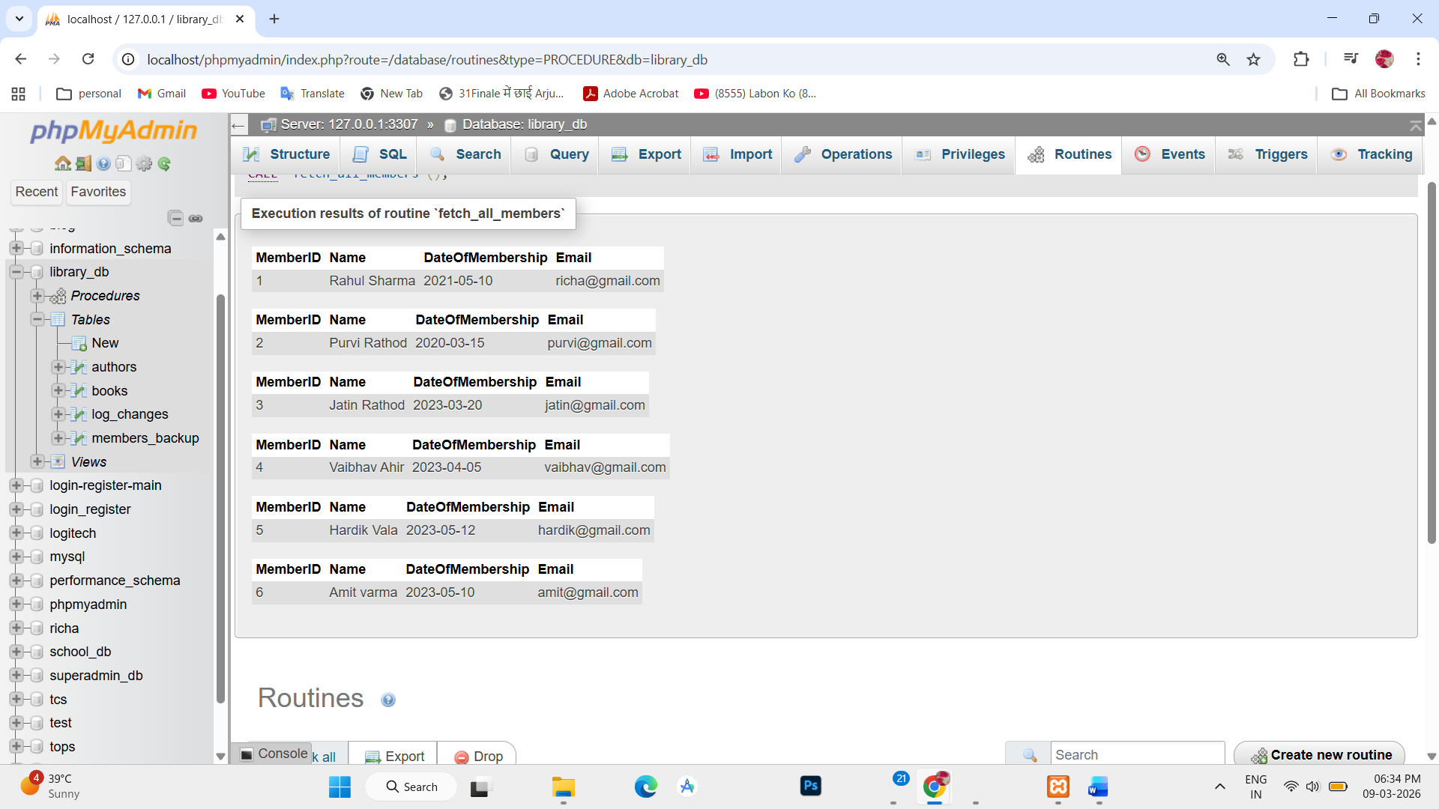

Lab 2.
Create a cursor to retrieve books by a particular author and display their titles.
Ans.
1. DELIMITER $$

CREATE PROCEDURE get_books_by_author(IN author_name VARCHAR(255))

BEGIN

DECLARE v_title VARCHAR(255);
DECLARE done INT DEFAULT 0;

DECLARE book_cursor CURSOR FOR
SELECT title FROM books WHERE author = author_name;

DECLARE CONTINUE HANDLER FOR NOT FOUND SET done = 1;

OPEN book_cursor;

read_loop: LOOP
FETCH book_cursor INTO v_title;
IF done THEN
LEAVE read_loop;
END IF;

SELECT v_title AS BookTitle;
END LOOP;

CLOSE book_cursor;
END$$

DELIMITER ;

